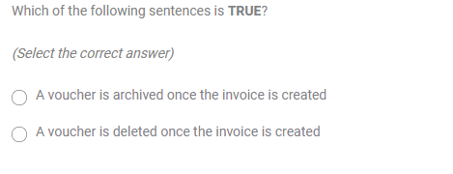

Answer: 2

Answer: 4

Answer: 2

Answer: 4

Answer: 2

Answer: 1

Answer: 2

Answer: 2